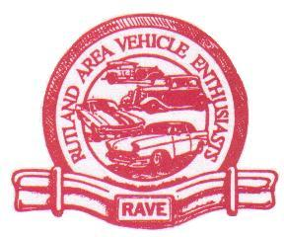
2023 RAVE CAR SHOW AND AUTO FLEA MARKET
PRESENTED BY R.A.V.E.
VEHICLE REGISTRATION FORM
$15.00 PRE-REGISTRATION BY JULY 1st/$20.00 AT SHOW

(all pre-registered vehicles will be eligible for a special prize drawing, Saturday the 8th-must be present to win)
FIRST NAME:_______________________________ LAST NAME:_______________________________
MAILING ADDRESS:___________________________________________________________________
CITY:_____________________________________ STATE:________ ZIP:_______________________
PHONE: ( ) ____________________ EMAIL:___________________________________________

VEHICLE INFORMATION:
YEAR:_______________ MAKE:_______________________________ MODEL:________________
COLOR:______________ ENGINE:______________________________________________________

CLUB AFFILIATION:___________________________________________________________________

Note: I hereby understand that I am responsible for my automobile and its contents or my wares and agree to release from all liability,
R.A.V.E. and its officers and members for any damages, injury, lost or stolen property incurred during this event.
PRINT, FILL OUT AND MAIL TO: R.A.V.E. – PO BOX 519 – WEST RUTLAND, VT 05777

